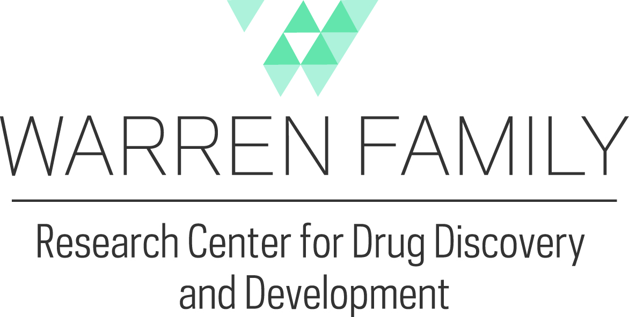
The Warren Family Center for Drug Discovery & Development (WFCDD) is a state-of-the-art resource for drug discovery researchers who have interest in the development of molecular probes, drugs, chemical tools, biological screens, or metabolomic assessments to study neurological and central nervous system disorders, infectious disease, cancer, rare diseases, or other issues of human health. Our Mission is to serve as a bridge that enables multidisciplinary collaborations and cross-institutional connections between researchers at the University of Notre Dame, as well as external partners, other academic institutions, and the pharmaceutical industry.
The Chemical Synthesis & Drug Discovery Facility supports translational biomedical research by providing expertise to enable the preparation of small molecules for use in hit validation, lead compound development, and midsize scale-up. In addition, the core supports the preparation of biological probes (aﬃnity, ﬂuorescence labeled, etc.), active pharmaceutical agents as experimental controls, and small chemical libraries for the establishment of preliminary structure-activity relationships and optimized pharmacological properties.
The Biological Screening and Assay Development Facility supports a broad range of pre-clinical drug screening and assay development platforms. It is capable of screening libraries of compounds for general and specific ADME-T needs; including liver microsome and plasma stability, plasma protein binding, blood brain barrier permeability, liver toxicity, hERG interaction, mutagenicity, bioenergetics (Seahorse), ligand-protein interactions (Monolith) and others. It also specializes in assay development, including the miniaturization, creation, or high-throughput adaptation of existing or novel assays to meet research needs. Using an automated liquid handling system, we can screen the Warren Center’s compound library in an assay of your choice to aid in hit identification or validation. The facility can also produce and purify recombinant proteins for biochemical and biophysical analyses. In addition, consultation is available to design, process, or analyze pharmacokinetic and pharmacodynamic studies for in vivo models.
Opportunities also exist to support collaborative efforts between the Computer-Aided Molecular Design Core Facility as well, which aims to provide a wide range of computational assistance from in silico screening to advanced computational analysis.
Funding:
The Center is looking to expand its interactions and collaborations on campus by providing resources (~$25,000) available within the core to support new and existing collaborations that utilize the core’s strength and expertise. No more than 3 applications will be funded during this period.

Deadline:
RFA closes November 15, 2019 (5pm EDT).
Award notification: December 1, 2019.

Application Guidelines:
Applicants should include a succinct 2-page proposal that succinctly describes the proposed work, the significance and impact of such studies, as well as a plan to pursue externally funded grants (also include an NIH Biosketch).
Drug Discovery and Development
Hit-to-Lead Optimization
Molecular Probe Development
Chemical Synthesis/Medicinal Chemistry
Pharmacokinetics/Pharmacodynamics
High-throughput Assay Development
Drug Metabolism/Stability/Toxicity
Rational Drug Design
Computational Analysis
In-silico screening

Please submit an electronic application in PDF format to:
Warren Center Coordinator (wrcadmin@nd.edu) no later than November 15, 2019.

