Director’s Note~
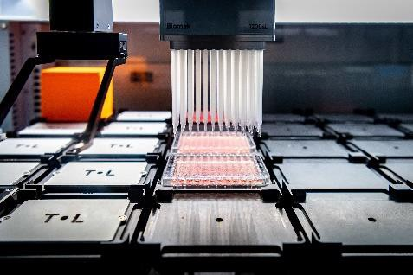
As the 2020 academic year comes to an end, a summary of this year’s accomplishments is provided in the annual Warren Roundup. First of all, members of the Warren Center want to thank both the Notre Dame community as well as members of the South Bend community for their valiant efforts at combating the Covid-19 coronavirus. While these efforts led to a pause in research, recent efforts have allowed our campus and community to prosper once again. Unfortunately, many of us lost loved ones due to the pandemic. We are sorry for these losses and hope for a full recovery for those that are still battling the virus. Dr. Aktar Ali has joined Notre Dame as the new Director of the Biological Screening and Development core (please see article below). In addition, new instrumentation has been obtained via financial support from the Scholl’s Foundation, which can be used by any member of the Warren Center. Pictures and details are provided in this newsletter. All three cores (computational, synthesis, and biological) are available to researchers at Notre Dame. The Warren Center also awarded the second annual Leahy-Filipi Family fellowship in neuroscience research, with a focus on drug discovery. This fellowship in neuroscience complements a graduate fellowship in Cystic Fibrosis research by the Welter Family Foundation. Please see the articles below to see who received these prestigious awards. A new RFA for each of these fellowships will be announced in the coming year.

Drugs in the Pipeline
Professors Mobashery and Chang continue to develop a drug for the treatment of diabetic foot ulcers, with the goal of starting clinical trials in the near future. Hsiri Therapeutics (Miller and coworkers) continue their collaboration with Shionogi and hope to develop a new treatment for Non Tuberculosis Mycobacterial (NTM) infections and targeted anti-TB agents. Mishra and Blagg started Grannus Therapeutics, which aims to develop new anti-cancer agents. Structured Immunity (Baker and colleagues) was launched in 2017 with the goal of partnering with established immunotherapy companies to help improve and optimize therapeutic pipelines via structural and computational biology. An investigational new drug, developed by the Blagg Lab, continues clinical evaluation for the treatment of neuropathies.

FREE Compound Screening

In an effort to facilitate collaboration and to enhance development of the Notre Dame library of small molecules, we will perform anti-proliferation assays against 5 cancer cell lines and an immortalized “normal” cell line to determine differential selectivities/therapeutic window. The compounds must be provided in >5 mg quantities and must be >95% pure and evidence of purity must be provided in the form of at least an 1H NMR spectra. The molecules will also be added to the Notre Dame library collection and will be screened against other targets during various high-throughput screening campaigns in the future. All biological data will be provided back to the PI. Please provide these molecules before the 1st of each month, as that is the date on which assays will be performed.

By the Numbers
Warren Center Researchers include 35 Principal Investigators, 31 Postdoctoral Researchers, 128 Graduate Researchers, 5 Research faculty, and 69 Undergraduate Researchers. Combined, we published 86 scientific articles in 2020, of which 16 resulted from collaboration with other Warren Center scientists, whereas 8 resulted from interdepartmental collaborations and 12 from departments within the Notre Dame campus. Warren researchers filed 27 US patents in 2020, whereas 6 US patents were issued and 1 start-up company was spun off to accelerate the drug discovery process. In addition, Warren researchers have requested more than $97,153,846 million
in federal grant support through 71 proposals, of which 31 were awarded.

COVID-19 Responders

2020 was a year like no other. The University of Notre Dame shut down in March of 2020 in response to the COVID-19 pandemic. The university was able to reopen labs in June 2020 with restrictions, such as 25% of normal density personal in the labs. Warren PI’s responded to the challenge.
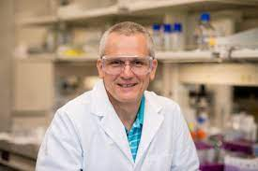
Merlin Bruening, the Donald and Susan Rice Professor of Engineering and concurrent Professor of Chemistry & Biochemistry. His group is developing porous affinity membranes that enable the rapid capture and analysis of antibodies. During flow through the membrane, antibodies rapidly bind to complementary groups, and subsequent capture of a labeled secondary antibody leads to a fluorescent signal that is proportional to the antibody concentration. The figure below shows an example for analysis of the anti-cancer antibody,
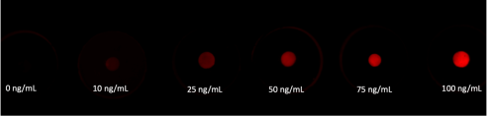
Bevacizumab. The fluorescence intensity of the spot increases along with the Bevacizumab concentration. Such analyses can occur in as little as 5 minutes and may allow determination of therapeutic antibody concentrations during an office visit. The Bruening lab is trying to develop a similar strategy to rapidly detect COVID-19 antibodies. In that case, we immobilize part of the COVID-19 spike protein for antibody capture. Unfortunately, quantitation of COVID-19 antibodies has proven much more difficult than analysis of therapeutic monoclonal antibodies.
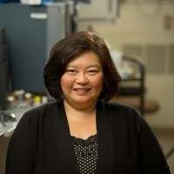
Mayland Chang, Research Professor of Chemistry and Biochemistry, received an award from Advanced Diagnostics and Therapeutics for “Inhibition of cathepsin-L by (R)-ND-336 as a treatment for COVID-19.” With support of the Department of Defense, Chang has been investigating the compound, (R)-ND-336, which was discovered at Notre Dame, as a potential treatment for diabetic foot ulcers. Chang and her team have found that this novel compound inhibits cathepsin-L, which has been shown to activate membrane fusion by the SARS-CoV S glycoprotein. The lab is investigating the potential use of (R)-ND-336 as a treatment for COVID-19 infection.
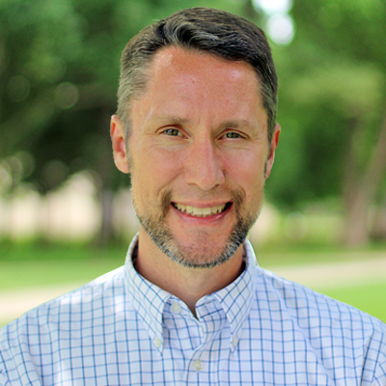
Joshua Shrout, Associate Professor of Civil and Environmental Engineering and Earth Sciences is working on a hallmark of moderate to severe COVID-19 pneumonia, which is termed acute respiratory distress syndrome (ARDS), via support from the NIH. Those with ARDS have greatly increased chance of secondary infections with bacterial pathogens. The Shrout lab is investigating the effect of two factors, hyaluronic acid and laminin, which are 10-100 fold increased in the lung during severe ARDS. In this research, they seek to characterize the behavior and growth of the lung pathogens Pseudomonas aeruginosa and Staphylococcus aureus, which are two of the top pathogens identified in SARS-CoV2/bacterial co-infections. They are working to characterize how hyaluronic acid and laminin promote the growth of these bacteria while simultaneously, characterizing biosignatures produced by these bacteria when growing on hyaluronic acid or laminin. They seek to exploit the presence of biosignatures for use in developing analytical diagnostics to more rapidly and effectively identify ARDS in its earliest stages of disease progression.
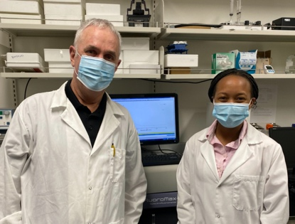
Pictured Bradley Smith and Janeala Morsby
Bradley Smith, Emil T. Hofman Professor of Science, is working on Acute Kidney Injury (AKI) which is the sudden loss of kidney function that results in damage to the proximal and distal convoluted tubular cells over a short period of time (hours to days). AKI is one of the common health problems that arise in patients during and after severe COVID-19 infection. Although the exact numbers are still being debated, there is clinical evidence that AKI (or subclinical AKI) is a strong predictor of people who, if infected with SARS-CoV-2, may end up requiring renal replacement therapy such as dialysis to slow the progression towards organ failure, a treatment option that is unavailable in many health care settings around the world. Moreover, a recent large-scale review of hospitalized US veterans found that nearly half of people with COVID-19 and AKI had unresolved AKI when the hospital discharged them. Many of these people will likely require continual kidney support after discharge. Racial identity appears to be an important factor and one recent study found Black people were 23% more likely than White people to develop COVID-19 related AKI after adjusting for other health factors. All of these reasons highlight the need for an efficient point of care detection method that allows individuals to detect early development of AKI and also to monitor kidney health for extended periods after recovery from COVID-19 infection.
Biochemistry graduate student, Janeala Morsby, working in the lab of Professor Bradley Smith is developing a simple urinary test that can be used to monitor changes in urinary N-acetyl-β-D-glucosaminidase (NAG) levels. NAG is an enzyme that is elevated in the urine of patients in the early stages of AKI. The urinary test utilizes a chemical substrate, which when cleaved by the NAG enzyme, releases a purple dye that can be captured by a test strip to give a dark color that is easily observed by the naked eye. To ensure that this urinary test follows the ASSURED: Affordable, sensitive, specific, user-friendly, rapid and robust, equipment free and deliverable guidelines, a four-step procedure is prepared to allow accurate determination of NAG enzyme levels in a urine sample. The steps are as follows: A 50 μL aliquot of a patient’s urine sample is added to a 1 mL solution of substrate in acidic solution. After a 15-minute incubation period, a 1 mL aliquot of stop solution is added and the final 2 mL sample is passed through a test strip which turns purple. The ColorPicker app on a cell phone is used to capture an image of the test strip and the R/B ratio reports the level of NAG enzyme. If the R/B ratio is below one, the test result is considered positive and serves as a prompt for a follow-up doctor’s visit for accurate clinical testing of kidney function. A manuscript is currently in preparation, which summarizes the results of this prototype study.

NSF Center for Computer Assisted Synthesis (C-CAS)
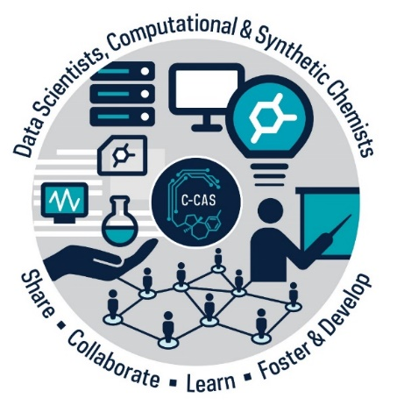
The Center for Computer Assisted Synthesis (C-CAS) is a newly awarded NSF Center for Chemical Innovation (CCI) dedicated to changing the way chemical synthesis is done by developing machine learning tools that help predict and understand chemical reactivity. The tools, workflows and datasets are disseminated to the scientific community, including 14 of the world’s largest pharmaceutical and chemical companies that are partners of C-CAS. In a recent paper published in Nature, C-CAS scientists demonstrated that machine learning can outperform more traditional reaction optimization by humans. Online training material developed in C-CAS makes these tools available to scientists everywhere and a variety of activities are targeted towards increasing the participation of underrepresented groups in science and to engage the broader community in a discussion of the opportunities and dangers of artificial intelligence in science. C-CAS is the first CCI at Notre Dame and is directed by Prof. Olaf Wiest at the University of Notre Dame, but also involves data scientists and computational & organic chemists chemist from Colorado State University, Princeton, Utah and UC Berkeley. Further information on C-CAS can be found at the center website at ccas.nd.edu.

Leahy–Filipi Graduate Fellowship
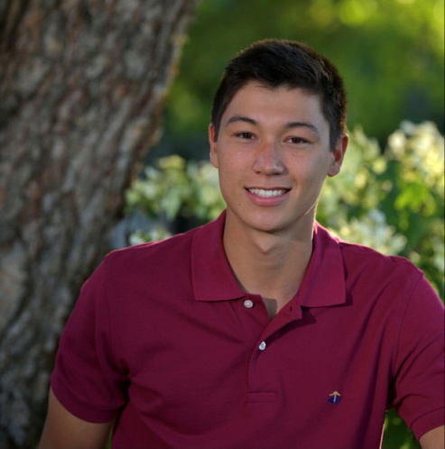
Benjamin Rajewski, a graduate student in the Del Valle lab, was the recipient of the 2021 Leahy–Filipi Family Endowment for Excellence in Neuroscience Research. The Leahy– Filipi endowment was established in 2019 by Rev. Jody Leahy Filipi and Dr. David H. Filipi, who was diagnosed with a rare neurological disease. The endowment was created with the ultimate goal of improving the quality of life for those afflicted by neurological diseases through funding of cutting-edge neurological research. Alzheimer’s disease (AD), characterized by declination of cognitive function and neuronal loss, accounts for roughly 70% of dementias, making it the most prevalent neurodegenerative disease plaguing humanity today. AD is linked to aggregation of the microtubule-associated protein tau into toxic neurofibrillary tangles. Rajewski’s project centers around developing selective inhibitors of tau aggregation and transmission, applicable not only to AD, but also to other tauopathies such as corticobasal degeneration, front temporal dementia, and Pick disease. He expresses his heartfelt thanks to the Leahy-Filipi family for their generosity in allowing him to pursue this research, as well as their commitment to the advancement of science and enhancement of the wellbeing of those living with neurological conditions. Congratulations.

Featured Faculty – Jeffrey Siwo
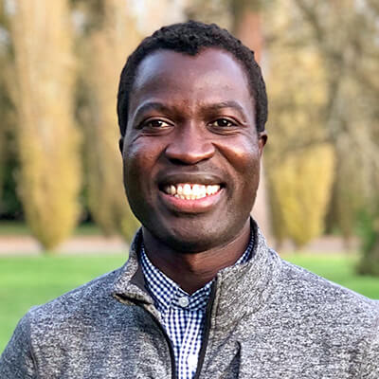
Dr. Geoffrey Siwo joined the University of Notre Dame in 2017 as an Assistant Research Professor at the Center for Research Computing and the Eck Institute for Global Health along with an appointment in the Department of Biological Sciences. Geoffrey received his undergraduate degree in Biomedical Science and Technology from Egerton University, Kenya (2005). In his second year at the University, he had a unique opportunity to perform research on retrovirus-like elements in the human genome at the Institute of Primate Research in Kenya. This experience sparked his interest in the potential biological implication of interactions between HIV-1, a retrovirus and the retrovirus-like elements that comprise 10% of the human genome. He became inspired to learn how to use computational methods to analyze openly available human and HIV-1 genome sequences in 2003. Such fascination would launch his career as a computational biologist.
Geoffrey received his PhD in Biological Sciences in 2014 under the supervision of Dr. Michael Ferdig, wherein he developed systems biology approaches to understand drug resistance evolution and drug mechanism of action. While at Notre Dame, he also became a co-founder of a startup- Helix Nanotechnologies- that is continuing to pioneer new synthetic biology tools with the support of several investors. After graduation from Notre Dame, he spent a short stint as a postdoctoral researcher at Dartmouth College and the University of Pennsylvania where he launched United Genomes Project, which was dedicated to increasing the representation of human genome sequences from African populations. He then joined IBM Research in 2015 as a Genomics Specialist at the IBM TJ Watson Research Center, New York, and transitioned to a Team Leader and Research Scientist of the Data Driven Healthcare team at the newly opened company’s lab in Johannesburg, South Africa.
At Notre Dame, he leads the Malaria DREAM challenge consortium that brings together several partners including the Bill and Melinda Gates Foundation, H3Africa Bioinformatics Network, and Sage Bionetworks to invite data scientists worldwide to contribute computational solutions to big challenges in malaria. His research at Notre Dame is the first to use natural language processing to automatically extract insights from thousands of scientific publications on gene editing technologies (CRISPR/Cas9), resulting in the first publication to detail the global distribution of over 10,000 researchers in this area of research, their institutional affiliations, the diseases they work on, and the emerging biases that could impact the use of gene editing. His research is also developing new methods to enhance the effectiveness and safety of gene editing technologies across genetically diverse individuals. He also leads the Vaccine Mapper project, which is tracking the biology of COVID-19 vaccines in development and a new initiative to develop artificial intelligence (AI) approaches for the discoveries of antiviral drugs that could be effective on a wide range of viruses, including SARS-CoV-2.
Geoffrey is the recipient of several awards including a TED Fellow (2014), Young African Committed to Excellence (2016), Quartz Africa Innovator (2017), IBM Faculty Award (2019) and Next Einstein Forum Fellow (2020). His work has been featured on several media including CNN, USA Today, Fast Company, Ozy, among other media.

Grannus Therapeutics
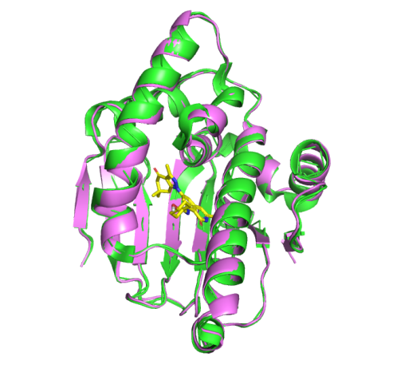
Grannus Therapeutics is an early-stage biotechnology company that was founded based on pioneering work performed in the Blagg lab regarding the development of isoform-selective inhibitors of Heat Shock Protein 90 (Hsp90). Dr. Sanket Mishra, who co-founded the company along with Dr. Blagg, completed his PhD from The University of Kansas in medicinal chemistry with Dr. Blagg. During his PhD, Dr. Mishra made several discoveries, one of which was the development of novel inhibitors of the Hsp90β isoform, which exhibited good potency and selectivity versus other Hsp90 isoforms. Excited with the finding, Dr. Mishra continued to optimize the compounds with the hope of obtaining a therapeutic candidate for cancer treatment, while a post-doctoral fellow at the University of Notre Dame. The use of Hsp90β-selective inhibitors offers multiple benefits over the pan Hsp90 inhibitors evaluated in clinical trials, which failed to gain approval due to dose limiting toxicities and/or lack of effectiveness, as these inhibitors inhibited all four isoforms with similar affinity. Currently, Grannus is engaged in the development of Hsp90β-selective inhibitors for the treatment of bladder, breast, and colon cancers, as well as leukemia. In this endeavor,
Grannus has received support from the National Cancer Institute in the form of a Phase 1 STTR grant. Another project that Grannus seeks to commercialize is the development of inhibitors that selectively target the Grp94 isoform, for the treatment of hereditary Primary Open Angle Glaucoma (POAG). Grannus is the first company to develop Hsp90 isoform selective inhibitors. At present, Grannus is located within the IDEA center, the University of Notre Dame start up incubator, and John Foglesong (Ex. Genentech) serves as the president and CEO of the company.

Featured Faculty –Aktar
Ali joins ND
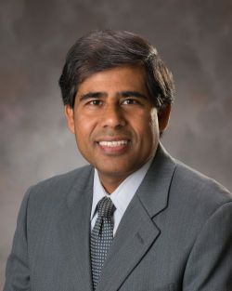
Dr. Aktar Ali, recently joined the Warren Family Center, as the Director of the Biological Screening and Development Core (BSDC). He has extensive experience in leading biomedical research as well as research core facilities. He led the Metabolic Phenotyping Core Facility (MPC) at UT Southwestern Medical Center in Dallas for over eight years. He also led the Biomedical and Obesity Research Core (BORC) at the University of Nebraska-Lincoln for two years. In addition, he assisted setting up the Translational Biomarker Core (TBC) at Montana State University. Before joining the Warren Center, he was leading a Mineral Metabolism Laboratory at UT Southwestern as the co-director of the facility. Dr. Ali received his Bachelor and Master’s degrees in Chemistry from the University of Chittagong, Bangladesh and his Ph.D. from Niigata University of Pharmacy and Applied Life Sciences, Japan. His postdoctoral training was in cancer biology at NYU Medical Center, New York.
Dr. Ali has been playing a significant role in basic medical research for the last 20 years. His research has been published in many peer-reviewed journals including “Free radical Biology and Medicine”, “Free radical Research”, “Cancer detection and prevention” “Cancer Discovery”, Cancer Research”, “Nuro-Oncology”, “International Journal of Oncology”, “Laboratory Investigation”, Neoplasia, “EMBO Reports”, “Oncogene”, “PLOS ONE”, “Biochemistry”, “PNAS”, “Cell Death and Diseases”, and “Nature Cell Biology”
Dr. Ali’s current research focuses on the molecular and cellular mechanism of hypoxia induced cancer cell invasion, migration and angiogenesis. Glioblastoma is a devastating brain cancer for which conventional treatment such as surgery, radiotherapy and chemotherapy fail because these cancers are aggressively invasive and angiogenic. Glioma cells can easily invade surrounding normal tissue which then regrow into tumors. Rapid growing glioma cells behave metabolically different from normal cells and by reprogramming of the cellular metabolism during epithelial to mesenchymal transition(EMT), these cells increase glucose uptake and produce more energy, thus, become more invasive and resistance to anti-angiogenic therapy or radiation therapy. Therefore, it is a dire need to understand molecular events that cause metabolic alterations of invasive glioma cancer. Dr. Ali’s research investigates: a) The molecular events that involved in abnormal metabolisms and aggressive invasion and angiogenesis of glioblastoma cancer, b) small molecule inhibitors (anticancer and antiangiogenic agents) that have therapeutic potentials for this aggressive glioblastoma cancer.
Dr. Ali’s objective is to take BSDC to the next level cutting-edge facility that provides services for the Notre Dame community as well as external users from academia and industry. Dr. Ali is also highly interested in building research projects in cancer biology through collaborations with other investigators at Notre Dame and HCRI. Please contact him by email: aali4@nd.edu

Welter Family Graduate Fellowship in Science
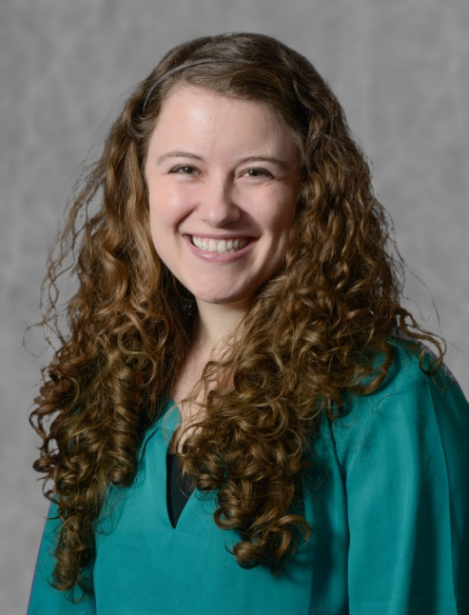
Karlie Cox, a graduate student in the Melander lab, is this year’s recipient of the Welter
Family Graduate Fellowship in Science for research on Cystic Fibrosis. The Welter Family
Fellowship in Science provides financial support to conduct research during the 2020-2021
academic year. This fellowship is focused on facilitating discoveries in cystic fibrosis research, which can include mechanistic studies, drug development, and/or related diseases, that affect those with cystic fibrosis (e.g., infections of the lung). Karlie’s proposal was entitled, “Using AR12 as an antibiofilm agent against mycobacteria relevant to cystic fibrosis lung disease.” Congratulations.

.The Biological Screening & Development Core (BSDC)
The BSDC is a state-of-the-art shared research facility established in the Warren Family Center and offers multidisciplinary cutting-edge drug discovery and translational biomedical research services for the Notre Dame investigators and also for external users. The goal of the BSD core is to assist its user scientists and provide both expertise and advanced technologies and assays in biomedical and drug discovery research. Using advanced equipment and automation services, we provide a full range of

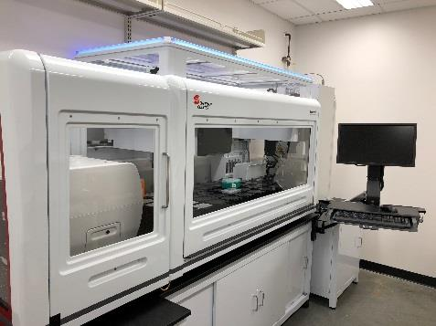
Biomek i7 Robotic Dual-Arm robotic liquid handler integrated with Cytomat2 cell culture incubator and cytation5 plate reader.

high-throughput pre-clinical screening (ADMET assays) for small molecule development; these assays include: Plasma Stability, Microsomal Stability, Hepatocyte Stability, Caco-2 Permeability and transport, PAMPA, Blood-Brain Barrier Permeability, Plasma protein binding, Protein-protein interaction, ligand-protein interaction, Primary Hepatocyte Toxicity, hERG Interaction, CYP Inhibition, CYP Induction and AMES Mutagenicity Test. The laboratory also offers a number of assays and equipment for biomedical research and includes cell culture facilities for both mammalian and bacterial cells, western blotting, qRT-PCR, DNA and RNA gel electrophoresis, ELISA, AlphaLISA, plasmid development, and cellular metabolic phenotype assays. Furthermore, the core is capable of generating and purifying recombinant proteins for use in in vitro assays.
Our live cell imaging automated platform featuring an automated BioSpa cell culture incubator (can hold 8 plates at a time) integrated with a Cytation5 microscopy system capable of imaging 96-well plates with three-channel fluorescence as well as bright field. This technology can be used on both 2D and 3D culture systems. With its combination of a hybrid plate reader and an advanced microscopy mode, the Cytation5 can be utilized for a wide range of assays including label free cell counting, calcium kinetics, time-lapse cell imaging, cell proliferation assays, cell viability/toxicity, cell migration, transfection efficiency, confluence, cytoplasm analysis, intracellular analysis, subpopulation analysis, signal translocation and much more.
Our Nanotemper Monolith and Tycho equipment, using microscale thermophoresis technique, quantitatively measure any type of biomolecular interactions (ligand-protein or protein-protein) in an easy, rapid, and accurate fashion. Thermophoresis (or thermo-migration) of bound or unbound molecules are detected and quantified using either covalently attached dyes, fluorescent fusion proteins, or intrinsic fluorescence. The Monolith instrument provides a flexible, robust, and highly versatile platform to measure molecular interactions. It can quantitate a dynamic range (nM to mM) of Kd values with a small sample volume (4μL). Tycho is an automatic protein analyzer that can reveal protein quality – presence, purity, concentration, functionality and similarity – all in one experiment and within 3 minutes using microliters of sample (10μl). It does this by measuring the protein’s structural integrity or foldedness in a label-free way.
Our most robust and high-throughput setting is Biomek i7 Robotic Dual-Arm and the 45 Deck Position Liquid Handling Automation Platform integrated with a Cytomat2 cell culture incubator and a Cytation5 multimode microplate reader with fluorescence, absorbance, luminescence and AlphaScreen detection capabilities. This high-throughput setting is a platform for ADMET assays for drug discovery screening as well as biomedical research application.
Our Agilent Seahorse XFe96 Analyzer measures real time kinetics of media flux within the live cellular environment, which can reveal the in vitro oxygen consumption rate (OCR), extracellular acidification rate (ECAR), or proton efflux rate (PER), in order to assess cellular metabolic functions such as oxidative phosphorylation, glycolysis, fatty acid oxidation and mitochondrial function. The XFe plate accommodates 96 individual wells, and up to 4 different test compounds (for example, Oligomycin, 2-DG, FCCP, Rotenone) can be injected separately into each well for real time kinetic experiments. The XFe assays apply to all fields of biomedical research including drug discovery, cancer, immunology, obesity/diabetes and neurodegenerative diseases.
Our Agilent 6460 Triple Quad LC-MS/MS with a 1290 autosampler is a gold standard for pharmacokinetic (PK), pharmacodynamic (PD), and bio-distribution studies for lead compound development. Other significant equipment include a GE AKTA FPLC for protein purification, BioRad ChemiDoc imaging and analyzing gel and western blots, AB StepOne real-time PCR system, BioRad C1000 thermocycler, several low and high speed centrifuges, digital sonicator, etc.
The Warren Center recently recruited Dr. Aktar Ali from the UT Southwestern Medical Center as the BSDC Director. Dr. Ali has extensive experience of leading biomedical research core facilities. He has been running the BSDC with his staff scientist Dr. Monimoy Banerjee.
For more information, please contact:
Professor Aktar Ali
Department of Chemistry and Biochemistry
University of Notre Dame
305B McCourtney Hall
Notre Dame, IN 46556
E-mail: aali4@nd.edu
Tel: (574) 631-2363
You may also contact Dr. Monimoy Banerjee by email: mbanerjee@nd.edu

The Chemical Synthesis Core
The Chemical Synthesis and Drug Discovery (CSDD) Facility that is overseen by Professor Brandon Ashfeld supports translational biomedical research by providing expertise that enables the preparation of small molecules for use in hit verification, lead development, and midsize scale up. In addition, the core prepares biological probes (affinity or fluorescently tagged), active pharmaceutical agents as experimental controls, and small chemical libraries for structure-activity relationships as well as the optimization of pharmacological properties. The CSDD coordinates the organizational oversight of compounds from past, current, and future chemical synthesis endeavors that comprise the Notre Dame Chemical Compound Collection, which currently contains ~5000 unique chemical entities. The CSDD is staffed with PhD level scientists (research scientists and postdoctoral research associates) with expertise in multi-step organic synthesis, medicinal chemistry, parallel development, and purification and isolation of small molecules. Services that are offered include, but are not limited to:
- Parallel synthesis of small molecule libraries
- Single compound preparation (10 mg to 20 g)
- Synthesis of biological probe molecules
- Peptides Synthesis
- Purification of complex mixtures
- Sample plating and distribution
- Project development with a special emphasis on therapeutics development
- Consultation

For more information, please contact:
Professor Brandon L. Ashfeld
Department of Chemistry and Biochemistry
University of Notre Dame
305D McCourtney Hall
Notre Dame, IN 46556
E-mail: bashfeld@nd.edu
Tel: (574) 631-1727

The Computational Core
The Notre Dame Computer Aided Molecular Design (CAMD) Core Facility of the Warren Family Research Center for Drug Discovery and Development provides the full range of computational chemistry support, from atomistic modeling to assistance in proposal writing, for drug discovery and related areas to all groups on campus. CAMD computational scientists have extensive expertise in virtual screening for inhibitor design, including docking, scoring, MM/ PBSA calculations, library design and cheminformatics. CAMD expertise in molecular dynamics extends from standard MD to advanced methods, such as Long Timestep Molecular Dynamics (LTMD), to Free Energy Free Energy Perturbation and Nudged Elastic Band simulations. In the area of electronic structure calculations, the CAMD uses density functional theory (DFT), correlated quantum mechanics (QM) and hybrid quantum/classical calculations (QM/MM) methods. In addition to utilizing existing methodology, CAMD is actively developing new methods, such as Q2MM and Ensemble Rescoring. CAMD expertise extends to pharmacokinetics and predictive modeling, encompassing quantitative structure-activity relationships (QSAR), cheminformatics, library and ligand-based design, and network analysis.For more information, please contact:
Professor Olaf Wiest
Department of Chemistry and Biochemistry
University of Notre Dame
305E McCourtney Hall
Notre Dame IN 46556
E-mail: owiest@nd.edu
Tel: 574-631-5876

Three Researchers Awarded Grants to expedite Drug Discovery
The Warren Center for Drug Discovery and Development is a state-of-the-art resource for drug discovery researchers who have an interest in the development of molecular probes, drugs, chemicals tools, biological screens or metabolomic assessments to study neurological and central nervous systems disorders, infectious disease, cancer, rare diseases or other issues of human health. An RFA had been established to expand its interactions and collaborations on campus by providing resources within the core to support new and existing collaboration that utilizes the core's strength and expertise. Each researcher was awarded funds/services to cover the cost of research performed within the Warren Center.
Funding has been awarded to:
- Laurie Littlepage from Chemistry and Biochemistry to work with Brandon Ashfeld in Chemical Synthesis and Drug Discovery Facility.
- Rebecca Whelan from Chemistry and Biochemistry to work with Professor Aktar Ali in the Biological Screening and Development Facility.
- Brandon Ashfeld from Chemistry and Biochemistry to work with Professor Aktar Ali in the Biological Screening and Development Facility.
Congratulations.
Another request for applications will be announced during the fall of 2021 and will encourage utilization of the three cores.

New Instruments for
Agilent Seahorse XFe96 Analyzer

Our Agilent Seahorse XFe96 Analyzer measures real time kinetic of the media flux in live cellular environment to determine in vitro oxygen consumption rate (OCR), and extracellular acidification rate (ECAR) or proton efflux rate (PER), in order to assess cellular metabolic functions such as oxidative phosphorylation, glycolysis, fatty acid oxidation and mitochondrial function. The XFe plate accommodates 96 individual wells, and up to 4 different test compounds (for example, Oligomycin, 2-DG, FCCP, Rotenone) can be injected separately into each well of real time kinetic experiment. The XFe assays apply to all fields of biomedical research including drug discovery, cancer, immunology, obesity/diabetes and neurodegenerative diseases.

Seahorse XFe96 - Real time kinetic measurement of cellular metabolic functions in label free and non-invasive live cells

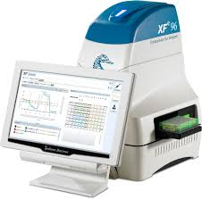

Cytation 5 Cell Imaging Multi-Mode Reader

Cytation 5 is a uniquely integrated, configurable system that combines automated digital widefield microscopy with conventional multi-mode microplate detection to provide phenotypic cellular information and well-based quantitative data.
- Microscope objectives(4x, 10x, & 20x
- Capable of brightfield(with and without phase contrast
- Three channel fluorescent imaging (DAPI, RFP, & GFP)

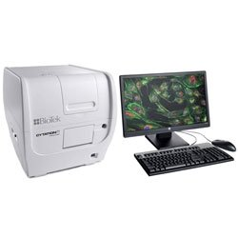

Use by Warren Center Researchers
Cytation 5 Integrated with a BioSpa Cell Culture Incubator.

Located immediately adjacent to our Beckman i7 Dual-Armed automation platform, these systems dramatically enhance Notre Dame’s drug screening and assay development capabilities.

- Proliferation assays
- Automated Wound healing/ Scratch assays
- 2D and 3 D cultures
- Cancer cell line, primary cell lines and stem cell lines
- On-demand scheduling
- Throughput workflow
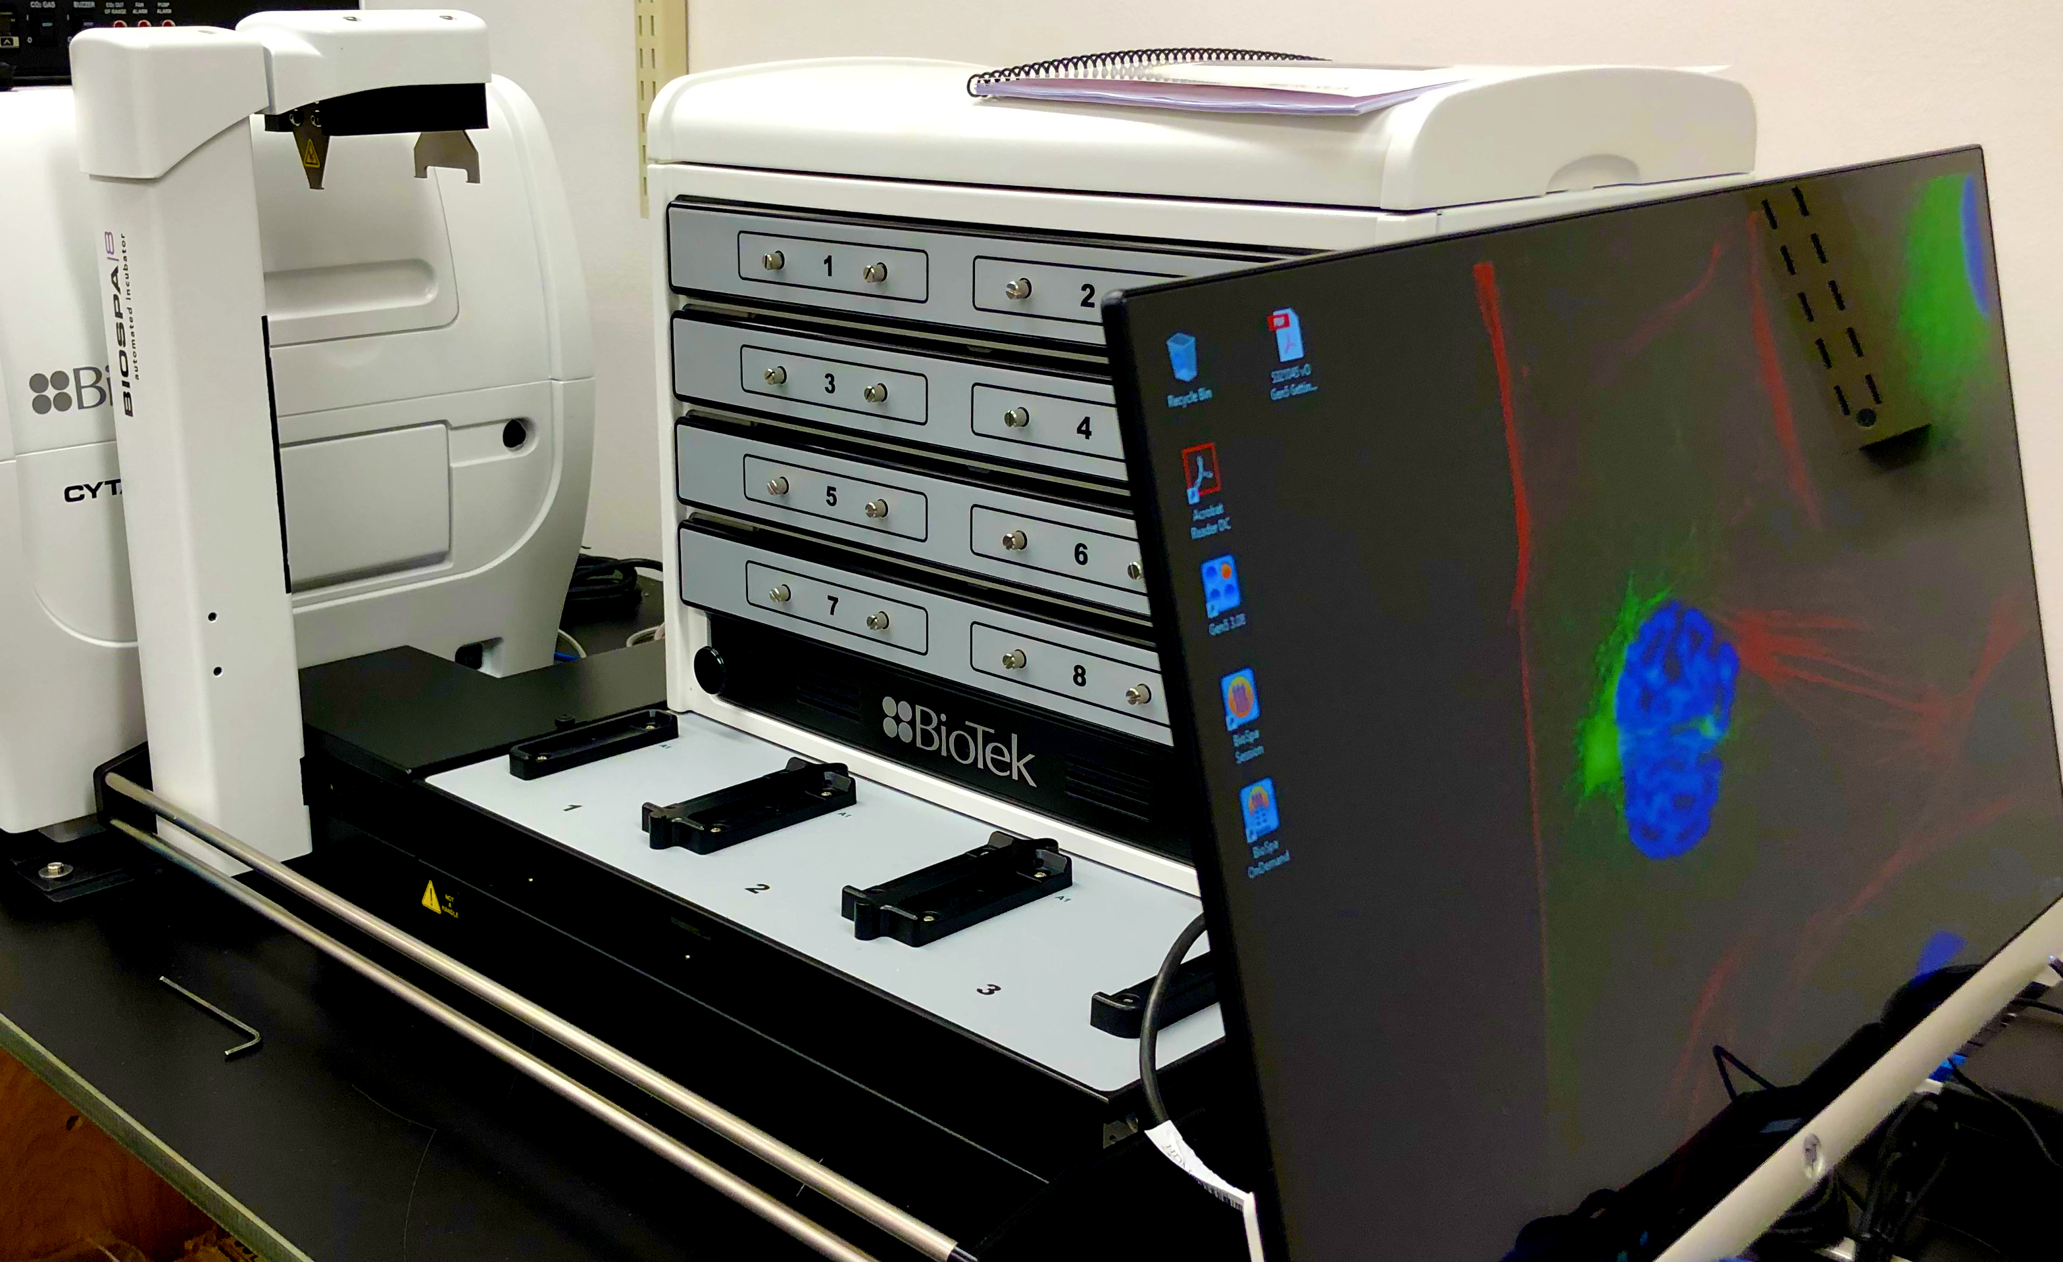

Cytation™ 3 Cell Imaging Multi- Mode Reader

Three-dimensional (3D) cell culture has become a well-established in vitro experimental approach as it provides an improved in vivo-like environment. The use of clear U bottom ultra-low attachment microplates that minimize cell adherence has become a standard for applications such as spheroid proliferation. Results shown here demonstrate the ability to generate quality results using both brightfield and fluorescence microscopy.
- Uses 3D Cell Culture
- Spheroid
- Hanging Drop Fluorescence
- Imaging Liver Microtissue
- Hypoxia
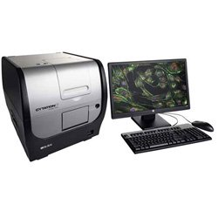

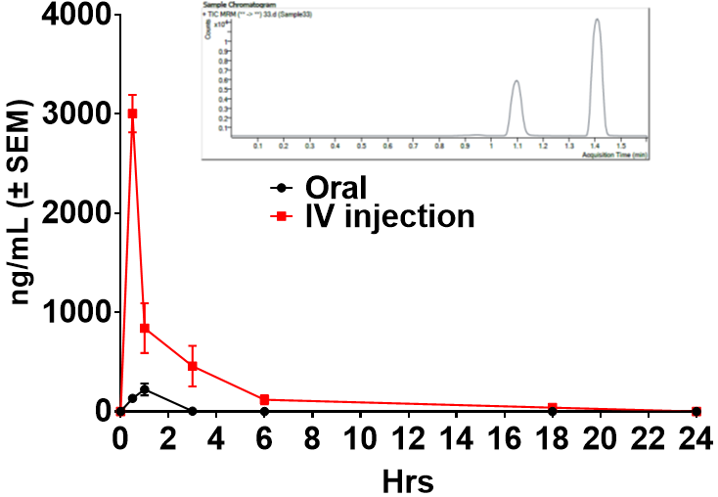

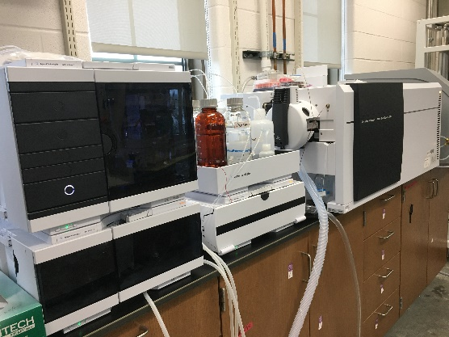

Triple Quad LC-MS/MS-PK
Study of a small molecule

Warren Lecture Series/ Seminar Speakers?
The Warren Center has established the Warren Lecture Series to invite guest lecturers to inform, share discoveries and scientific expertise within the Warren community. Due to COVID-19 the seminar series took a brief pause from in-person seminars and met via zoom. The Warren Center had one guest lecturer via zoom this past year and looks forward to welcoming more this coming fall. You can nominate a guest lecturer with strong expertise in drug discovery via email to wrcadmin@nd.edu or website at https://drugdiscovery.nd.edu/ seminars.

.

